

TEMENOS T24

Stream

User Guide

Table of Contents

Exchange Component - User Guide

Introduction 3

Preface 3

Overview 3

Exchange Calendar Component 3

Assumptions 3

Getting Started 4

Installation 4

Adding Exchange Calendar Component to a Solution 5

Using the Calendar 6

To Add an Appointment 7

Edit an Existing Appointment 8

Moving Appointments 9

Remove an Appointment 9

All Day and Recurring Appointments 9

# 

# Introduction

## Preface

This User Guide is intended for Developers and provides the step by step instructions for using the Exchange Calendar Component in your presentation.

## Overview

### Exchange Calendar Component

The Exchange Calendar Component allows users to see their calendars, as well as add/edit/remove new and existing appointments.

The component requires the credentials to be passed to it in order to connect to the Exchange service.

## Assumptions

It is assumed that you are familiar with the edgeConnect Editors and have working knowledge on edgeConnect, and an Exchange service is running, either in the organisation or in the cloud (Office365).

# Requirements

The sources of the Exchange component depend on the following jars:

- Specific (available under the provided Solution/WEB-INF/lib)

joda-time-2.7.jar

commons-codec-1.9.jar

These need to be added to the java path in the Developer.lax file

- Common (available under IDE/lib)

Acquire.jar

iforms.jar

commons-logging-1.1.1.jar

httpcore-4.3.2.jar

httpclient-4.3.4.jar

These should be already present in the java path in the Developer.lax file; no change required. The sources used by this Integration component are compiled and packaged in the Exchange Solution under Solution/WEB-INF/lib/exchange-calendar.jar.

When including this component into another solution, copy into its WEB-INF/lib folder the following jars from Solution/WEB-INF/lib :

exchange-calendar.jar

joda-time-2.7.jar

commons-codec-1.9

NOTE: A certificate file might be required from the Exchange server to connect to it.

# Getting Started

## Installation

For manual installation:

1. Copy **com.temenos.components.exchange.calendar** folder in your components folder (Ex: /{your project/../Components }).
2. Restart IDE.

For auto-installation:

1. Run IDE.
2. Make sure ‘Switch Monitor on/off’ is checked.
3. Download or copy the component **com.temenos.components.exchange.calendar.zip** to the monitored folder.

(Navigate to **Tools** - > **Options** -> **Auto-install** and set in **Download Location**, the folder where you copied the component.). There is no need to restart IDE.

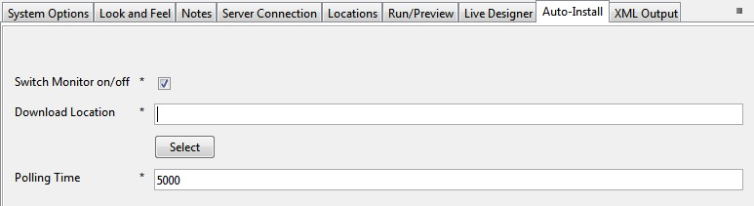

## Adding Exchange Calendar Component to a Solution

First, add a new item group component to a phase. In the “Component” tab, navigate to the Calendar ifp (in UI/Calendar), then select the ViewCalendar component from the list.

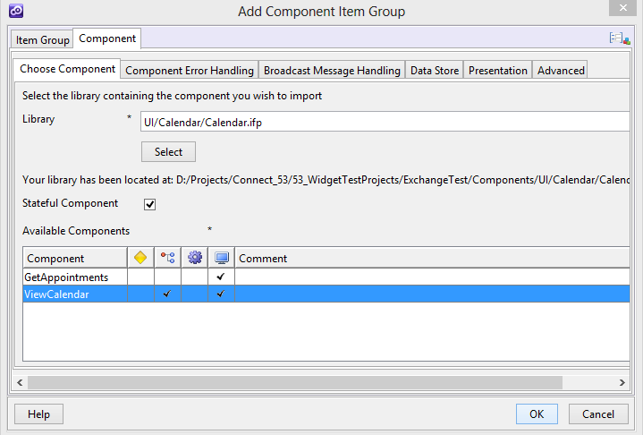

The datastore in the component requires some values. Map these to local values in the solution, which should contain the credentials of the email account to access.

A number of credential parameters are required by the component. It is expected that the caller of the component will pass these values in via data item mapping.

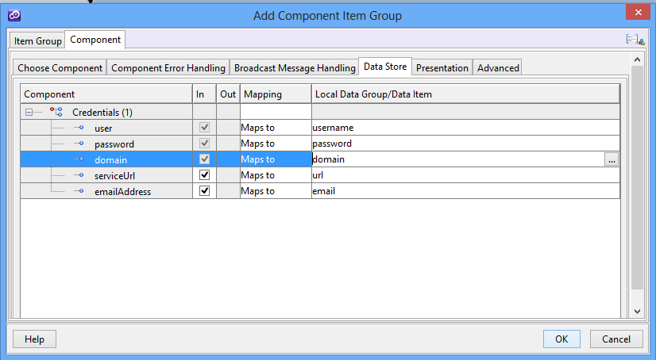

Then make sure the solution values are populated (either with rules/data set/user input) and run the project.

## Using the Calendar

The initial view

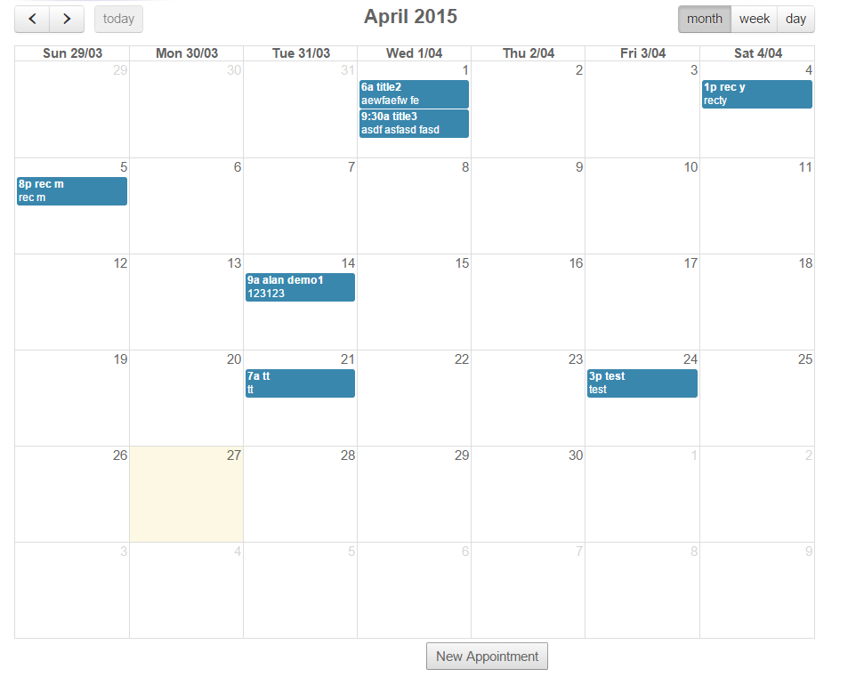

### To Add an Appointment

Click the “New Appointment” button at the bottom of the calendar view. This brings up the new appointment dialog:

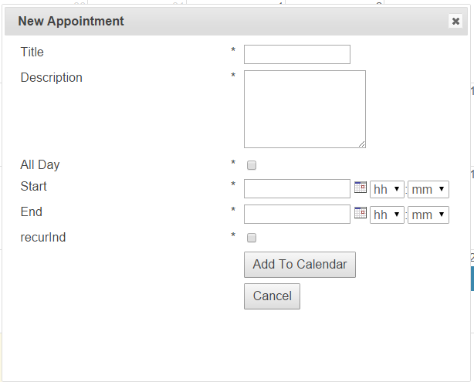

Enter the details as required, and click “Add To Calendar”. A new entry will be created in the user’s Exchange calendar, and the view will be updated to show the new appointment.

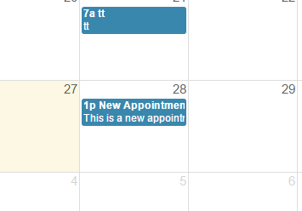

It is also possible to add a new appointment from the day view. Click on the day box (this will change the view to day mode).

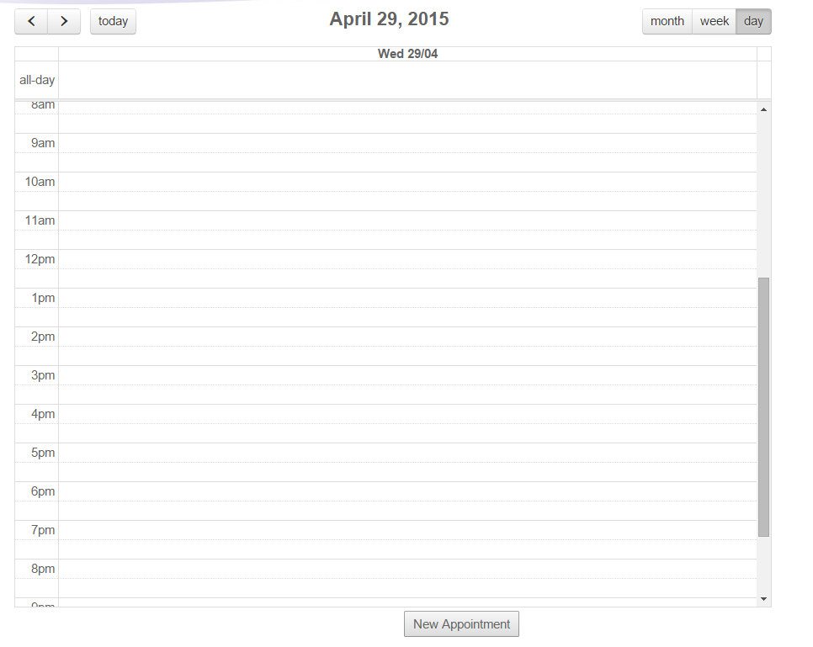

Then click in the day where you want your appointment, and the day and time will be pre-populated in the dialog:

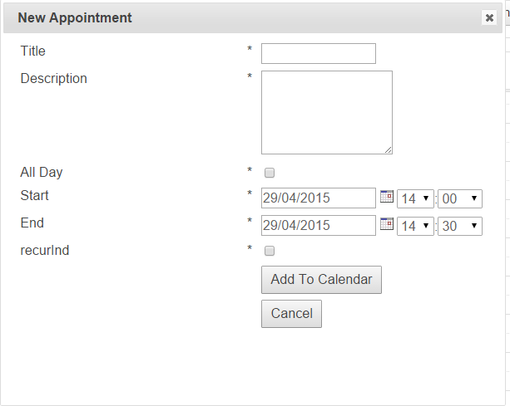

### Edit an Existing Appointment

Clicking on one of the calendar entries will launch the Calendar Summary dialog. This shows the details of the appointment:

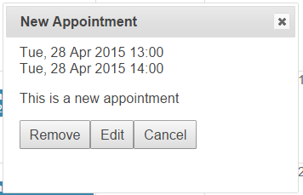

Clicking “Edit” will launch the New Appointment dialog, but with the values populated from the current appointment. When you have made the desired changes, click “Update” to save.

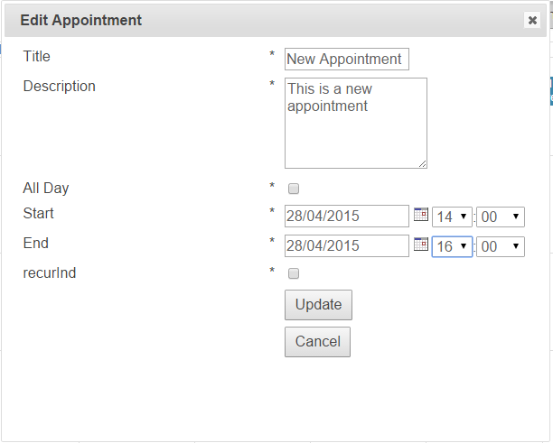

Clicking “Cancel” will not save the changes and the dialog will close.

### Moving Appointments

It is possible to move existing appointments (or extend them) using “drag and drop”. Say for example, we wanted to move an appointment from 28th April to the 29th April, we can click on the appointment (without releasing the mouse) and move the mouse until it is over the 29th April. Then we release the mouse. A confirmation will be shown with the new appointment details. The user can confirm or cancel these changes.

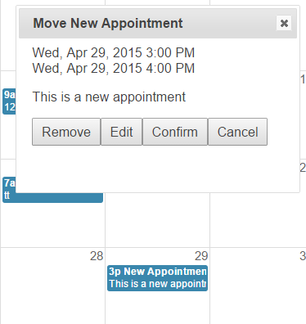

To change the duration of an appointment, go to day view and drag the bottom of the appointment to the required end point.

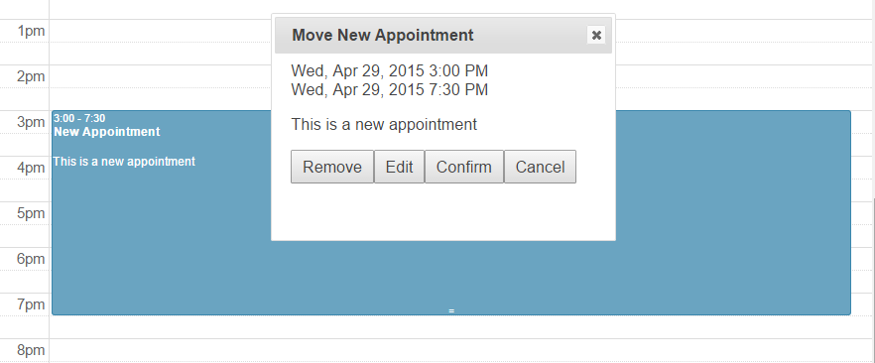

### Remove an Appointment

To remove an appointment from a calendar, click on the entry to bring up the summary, and click the “Remove” button.

### All Day and Recurring Appointments

To make an all-day appointment, select the “All Day” checkbox. In the day view, this will appear in its own section at the top of the page.

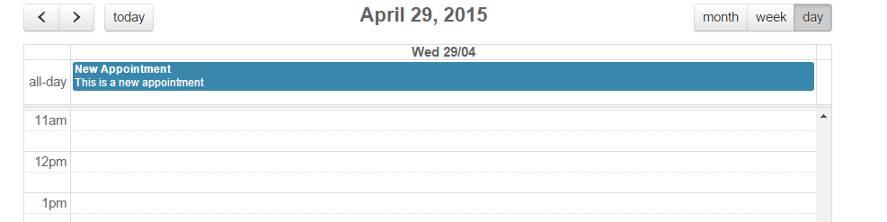

To make a recurring appointment, select the Recurring checkbox, and the select the two further recurring options. These are whether to recur:

* Daily
* Weekly
* Monthly
* Yearly

And to specify how long to recur for (i.e. when the recurring ends).

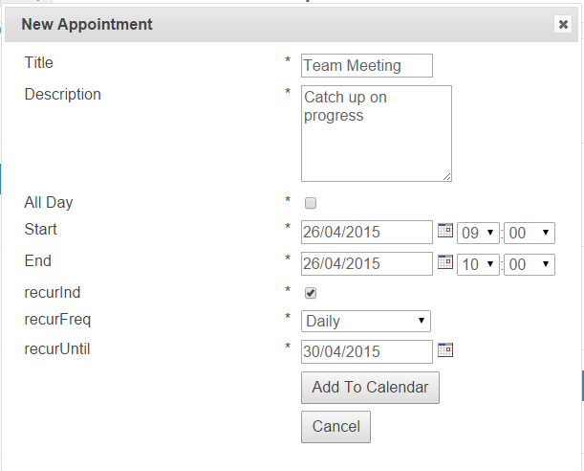

Results in the following:

